PJSip compilation

На сайте <https://www.pjsip.org/> находим ссылку где взять последние исходники

Скачиваем.

В папке pjlib\include\pj\ создаем файл config_site.h с содержанием:

// Uncomment to get minimum footprint (suitable for 1-2 concurrent calls only)

//#define PJ_CONFIG_MINIMAL_SIZE

// Uncomment to get maximum performance

#define PJ_CONFIG_MAXIMUM_SPEED

#define PJ_DLL 1

#define PJ_EXPORTING 1

#define PJ_EXPORT_SPECIFIER __declspec(dllexport)

#define PJ_IMPORT_SPECIFIER __declspec(dllimport)

#include <pj/config_site_sample.h>

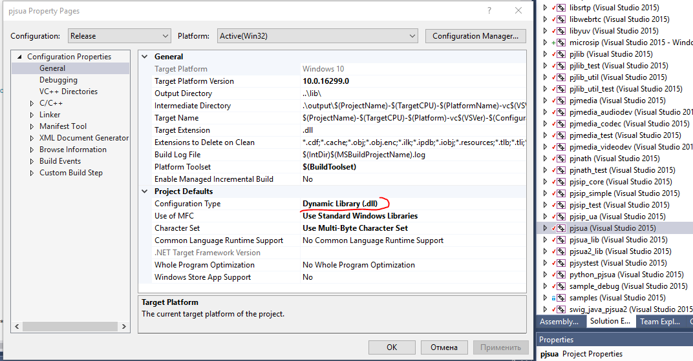

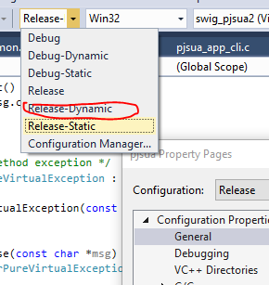

Компилируем. Скорее всего выдаст ошибку что cli_get_info(info, sizeof(info)); уже объявлен. Переименовываем в cli_get_info2 меняем 2 зависимости от этого метода.

После успешной компиляции займемся SWIG (инструкция для питона)

2

I could make a workaround to compile pjsua2 for Python 3.7. If you have a better solution or just suggestion to this workaround, let me know

Preconditions:

* List item
* Download and extract swig (swigwin 4.0.0)
* Download and install JDK
* Download and install Python (Python 3.7.3 x64) and set at custom installation:
  + tick "Add Python to environment variables"
  + tick "Precompile standard library"
  + tick "Download debugging symbols"
  + tick "Download debug binaries (requires VS 2015 or later)"
  + set custom path if you want
  + add swigwin location to system path
  + add Python location to system path
  + add JAVA_HOME system variable
  + add %JAVA_HOME%\bin to system path
  + Install Visual Studio 2015 Community edition

Steps:

* Download and extract pjsip 2.8
* Create empty config_site.h under pjlib/inlclude/pj/ folder
* Open pjproject-vs14.sln in VS
* There will be an unsupported warning window, press OK
* At the "Install Missing Features" windows, press install
* VS installer will be started, and VS has to be closed to complete installation.
* I have also added "Windows 10 SDK (10.0.10586)" to the installation.
* I have also enabled developer mode on my Windows 10, but this could be optional
* Open project again in VS
* Set project to Release and x64 on the top dropdown
* Right click on the solution, and go to Configuration Properties> Configuration
* Remove all uwp and wp8 related projects from selection, like pjsua_cli_uwp_comp, pjsua_cli_wp8_comp
* press OK, and build solution
* I have had 34 succeeded and 0 failed solution after build.
* Add following lines to pjsua2.i in pjsip-apps/src/swig folder
* %inline %{
* pj_ssize_t new_pj_ssize_t(int s) {
* return (pj_ssize_t) s;
* }

%}

this extra inline swig function provides workaround for create recorder [issue](http://lists.pjsip.org/pipermail/pjsip_lists.pjsip.org/2018-August/041060.html)

* Open a command line (powershell did not work for this)
* go to pjsip-apps/src/swig/python
* Execute following command:

swig -I../../../../pjlib/include -I../../../../pjlib-util/include -I../../../../pjmedia/include -I../../../../pjsip/include -I../../../../pjnath/include -py3 -c++ -python -threads ../pjsua2.i

ДЛЯ C#

swig -I../../../../pjlib/include -I../../../../pjlib-util/include -I../../../../pjmedia/include -I../../../../pjsip/include -I../../../../pjnath/include -c++ -csharp ../pjsua2.i

* Add new "Empty Project" (Visual C++) to solution with swig_python_pjsua2 name
* Add libpjproject and pjsua2_lib as reference to this new project
* Right click on the Header Files>Add>Existing Item...
* Add pjsip-apps\src\swig\pjsua2_wrapp.h
* Add a "new filter" to the project with name "Generated Code"
* Right click on "Generated code" and add new existing item.
* Add pjsip-apps\src\swig\pjsua2_wrapp.cxx
* Right click on the project and Linker>Input
* Add "Ws2_32.Lib" to "Additional Dependencies"
* Go to "VC++ Directories"
* Add following folder to include path(I have used full path!):
  + c:\python37\include
  + pjnath\include
  + pjsip\include
  + pjmedia\include
  + pjlib-util\include
  + pjlib\include
* Add following folder to Library Directories:
  + C:\Python36\libs
* Set at General:
  + Target Name: _$(ProjectName)
  + Target Extension: .pyd
  + Configuration Type: Dynamic Library (.dll)
* Go to properties of the solution, and select swig_python_pjsua2 to build
* Right click on swig_python_pjsua2 and build
* Build should complete successfully
* You will need to file to use pjsua2 library in python.
* pjsua.py located under pjsip-apps/src/swig/python
* x64/Release/_swig_python_pjsua2.pyd (rename this to _pjsua2.pyd)
* To test, copy those to file into a folder, start python from same folder and type:
  + import pjsua2

После успешной компиляции Все файлы *.cs включаем в C# project. (Class Library)

create new c# project and add all SWIG generated cs files (few changes are needed);

Подключаем проект к нужному и компилируем. Не забываем копировать pjsua2.dll в конечную папку